**Engineering Management Principles and Economics**

**ENGR301**

**Tutorial 2**

Below are sample Work Breakdown Structures for building a house:

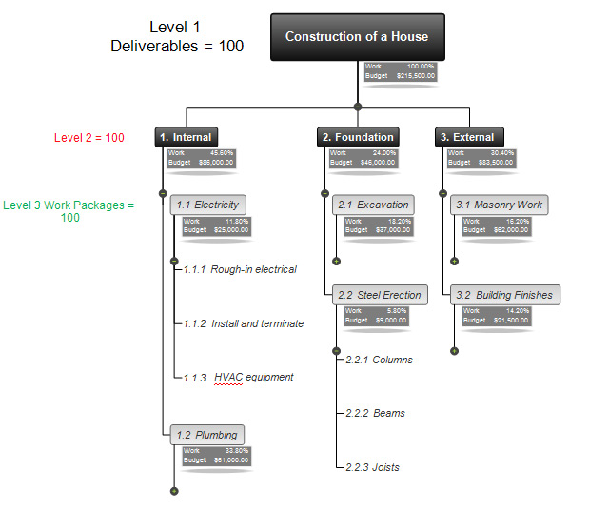

**Source: http://www.matchware.com/en/templates/wbs-template-construction-of-a-house.php**

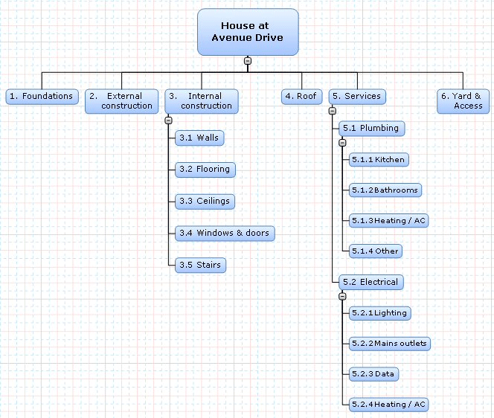

**Source: http://www.matchware.com/en/products/mindview/mindview2_be/wbs.htm**

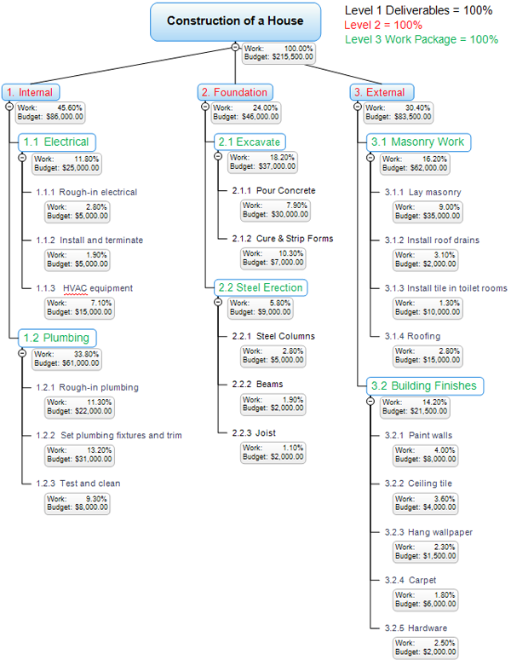

**Source: https://www.workbreakdownstructure.com/100-percent-rule-work-breakdown-structure.php**